TuteDude Flask and MongoDB Assignment
- JSON API Route
- Create a Flask application with an /api route.
- When this route is accessed, it should return a JSON list.
- The data should be stored in a backend file, read from it, and sent as a response.

- Creating the virtual environment in Linux terminal.
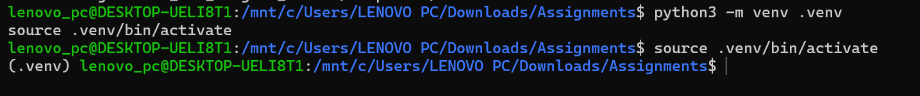
- Installing project dependencies
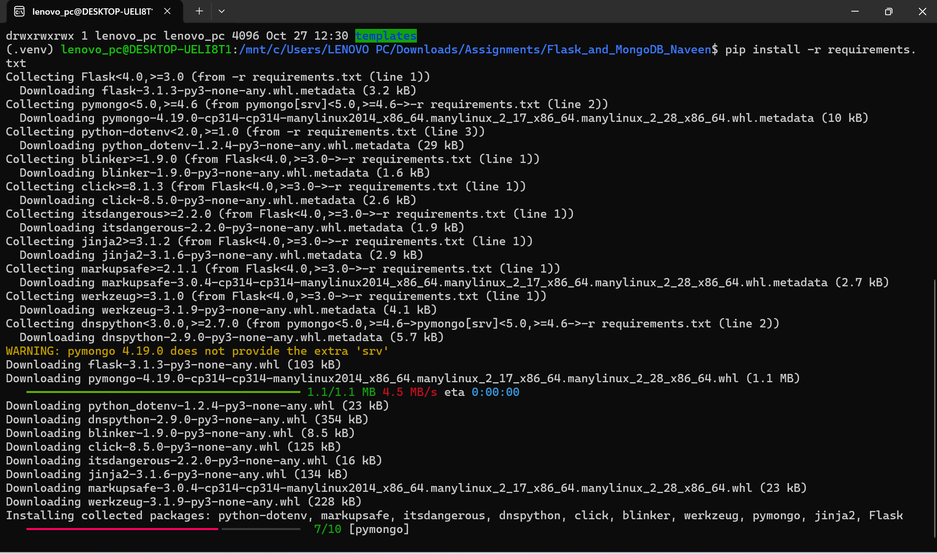

- Installing Flask and MongoDB Application
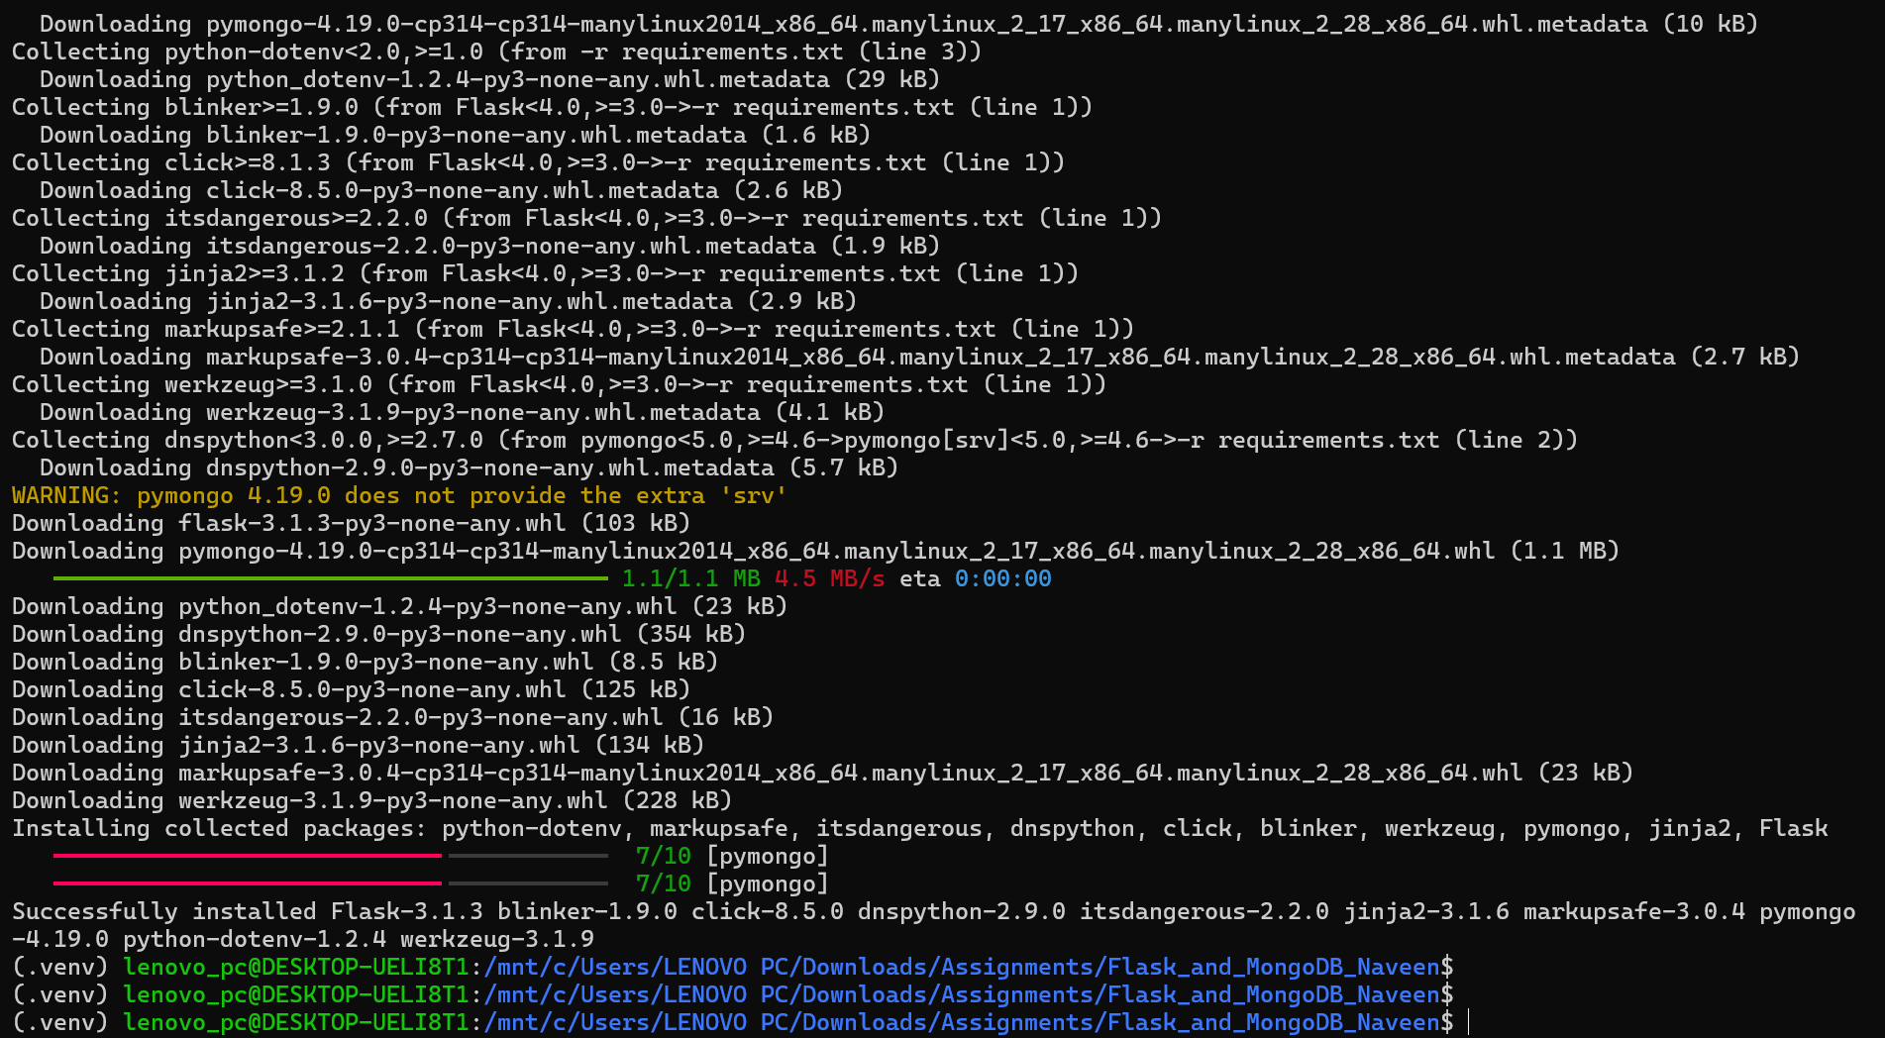
- Run Flask application.
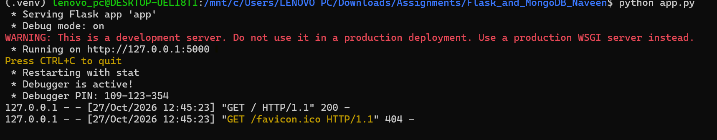
- Visit browser and open the mention URL - http://127.0.0.1:5000/
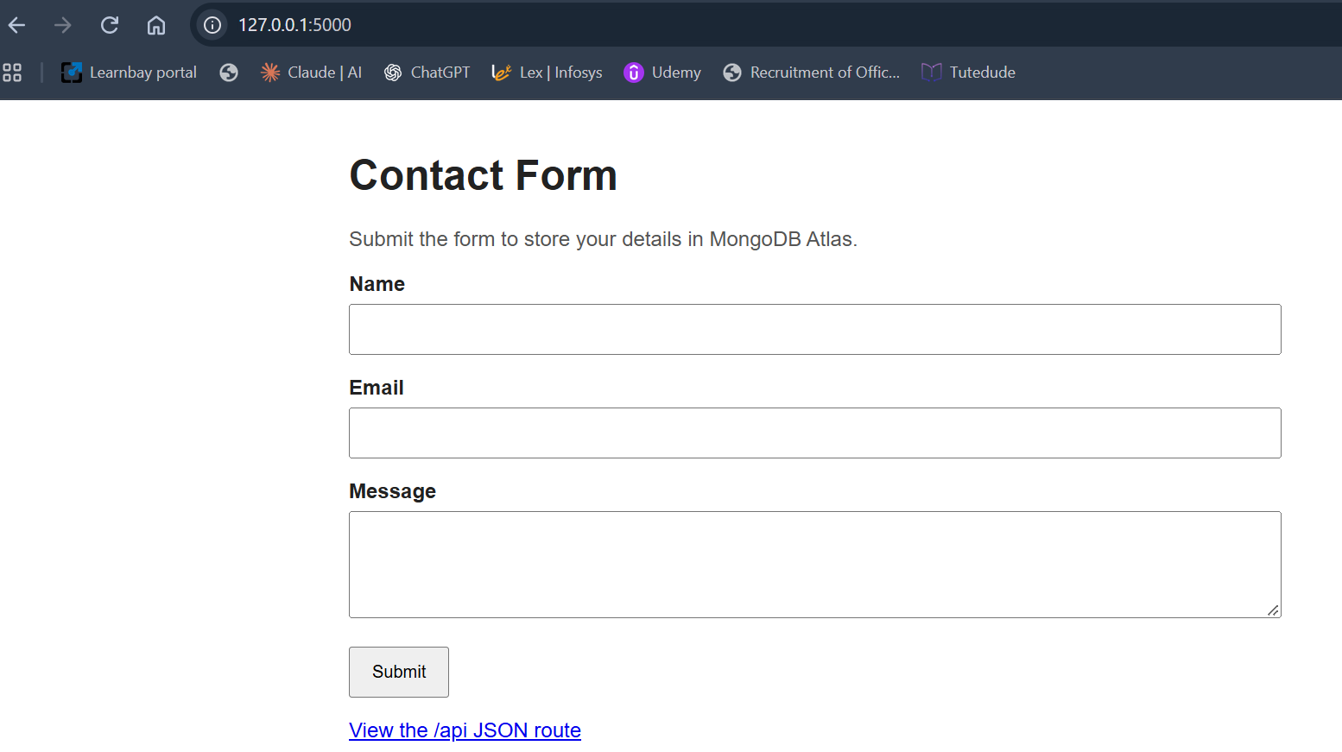
- The application reads this list from data.json each time the API is requested.


